Reason for consulting this office:______________________________________________________
Expectations regarding treatment:_______________________________________________________

Please Circle: (No Complaint/Pain) 0 1 2 3 4 5 6 7 8 9 10 (Worst Possible Complaint/Pain)
Using the symbols below, mark on the pictures where you feel pain.
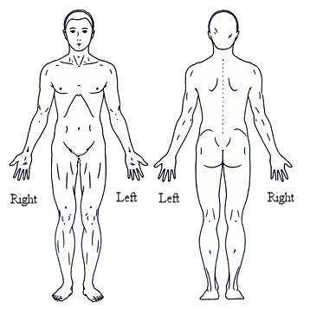

Numbness = = =

Dull Ache OOO

Burning XXX

Sharp/Stabbing / / /

Pins, Needles + + +

Other ______ ^ ^ ^

Please mark any of the following conditions or symptoms that you have now or have experienced:
Other Symptoms:
O Headaches O Pain in Hands or Arms O Chest Pains
O Neck Pain O Numbness in Hands or Arms O Heart Attack
O Sleeping Problems O Pain in Legs or Feet O High Blood Pressure
O Low Back Pain O Numbness in Legs or Feet O Stroke
O Nervousness O Fatigue O Cancer
O Tension O Depression O Painful Urination
O Irritability O Lights Bother Eyes O Diabetes
O Dizziness O Loss of Memory O Diarrhea
O Pain Between Shoulders O Shoulder Pain O Constipation
O Neck Stiff O Sinus O Stomach Upset
O Joint Swelling O Shortness of Breath O Heartburn/Reflux
O Fever O Asthma O Weight Loss
O Loss of Balance O Allergies O Loss of Smell or Taste
O Ringing in Ears O Cold Hands O Menstrual Cramps
O Jaw/TMJ Problems O Cold Feet O Menopause

I hereby certify that the statements and answers given on this form are accurate to the best of knowledge and understand it is my responsibility to inform this office of any changes in my health.
Patient Signature______________________________________________________Date__________________

