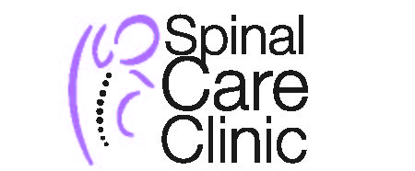

Thank you for choosing Southmount/Halton Physiotherapy as your rehab treatment center.
FEES & PAYMENT

Current fees are as follows:

Physiotherapy Assessment – $85.00 Physiotherapy Treatment – $70.00 Yoga (1 hour session) - $80.00
Pelvic Physiotherapy Assessment - $120.00 Pelvic Physiotherapy Treatment - $80.00
Chiropractic Assessment - $85.00 Chiropractic Treatment - $45.00
Massage Therapy – 90 min $ 115.05 + HST, 60 min $75.23 + HST, 45 min $65.00 + HST, 30 min $50.00 + HST
Payments for services are the responsibility of the patient and are to be paid at each visit. If a third party payer (ie. EHB) denies or partially pays the amount billed; you are responsible for paying the outstanding amount.
Please note: A $25.00 cancellation fee will be charged with less than 24 hours notice on any cancellation.
I understand the fees and payment policy
Patient Name: ______________________________________ Date:
Signature of patient: ________________________________

General Information Questionnaire

Your information is helpful to us; however the following 2 questions are for statistics only and are not compulsory

Return Patient Yellow Pages Internet
Family Doctor _____________________ Specialist __________________
Friend / Family ____________________
Name of referral
How did you
hear about us?

Referred Here Location / Hours First Clinic I called
Cost Other: ________________
Why did you
Choose us?

Can we email your appointment reminders to you? YES NO

If yes, please print your email address clearly: __________________________________________________
*By providing your email address, you consent to us sending you email communication with respect to appointment reminders and clinic information
Signature: ________________________________________

